**Project Report Format**

# 1. INTRODUCTION

## 1.1 Project Overview

Economic freedom plays a critical role in determining a country's prosperity, competitiveness, and the overall well-being of its citizens. However, while numerous datasets and reports exist, there is a gap in interactive and comparative tools that make this information accessible and actionable for diverse stakeholders.

This project aims to analyse and visualize the Index of Economic Freedom across multiple countries to provide insights into the relationship between economic policies and national prosperity. Using statistical analysis, data visualization techniques, and real-time filtering capabilities, the platform enables policymakers, researchers, investors, and the general public to explore key economic indicators in an intuitive and meaningful way.

The solution integrates data ingestion, processing, and visualization in a modular architecture, offering features like global freedom heatmaps, year-wise trends, top/bottom ranked countries, and correlation analysis with other socio-economic metrics like GDP and unemployment rates. This project bridges the gap between raw data and informed decisionmaking through a transparent, scalable, and user-centric approach.

## 1.2 Purpose

The purpose of this project is to create an accessible, data-driven platform that enables the analysis and visualization of the Index of Economic Freedom across different countries and time periods. This initiative seeks to empower policymakers, researchers, and investors by providing them with actionable insights into how economic freedom influences prosperity, governance, and development. By transforming complex datasets into interactive dashboards and comparative tools, the project promotes informed decision-making, encourages transparency in economic policies, and supports academic and institutional research. Ultimately, the solution aspires to highlight global economic patterns and guide strategic reforms aimed at enhancing economic liberty and growth.

# 2. IDEATION PHASE

## 2.1 Problem Statement

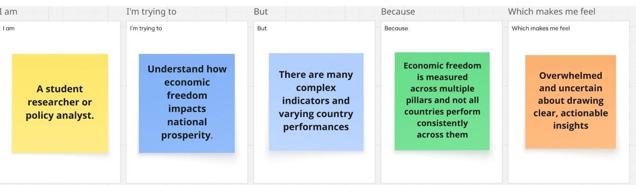

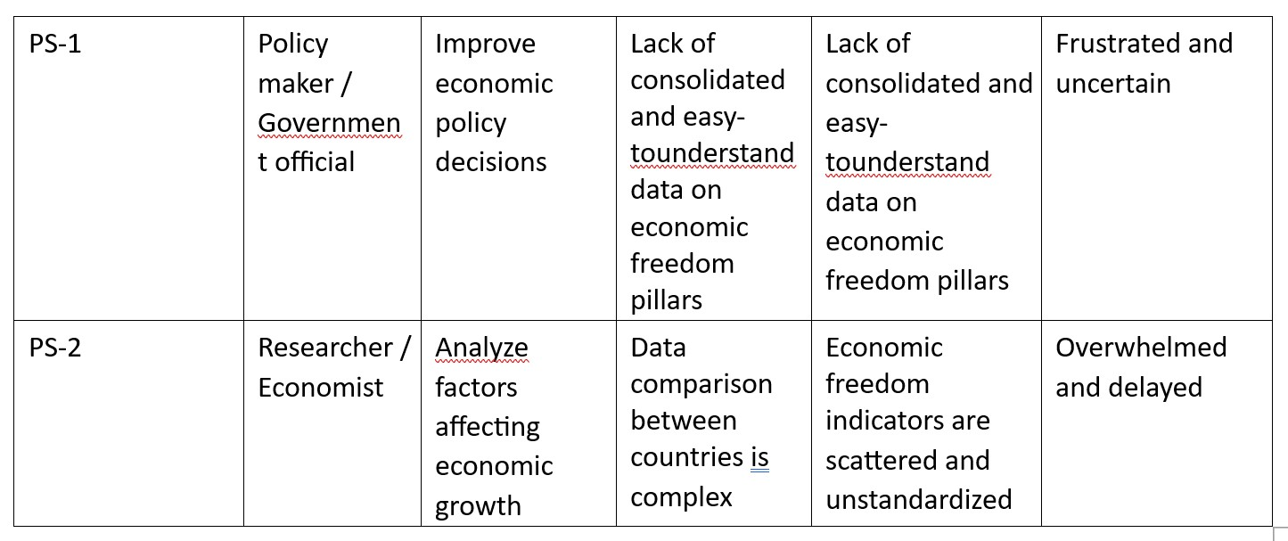

## 2.2 Empathy Map Canvas

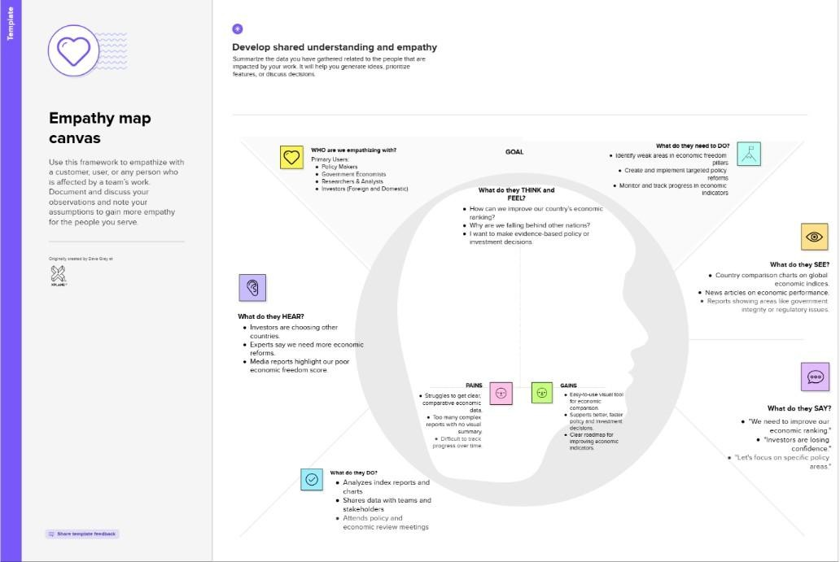

## 2.3 Brainstorming

**Step-1: Team Gathering, Collaboration and Select the Problem Statement**

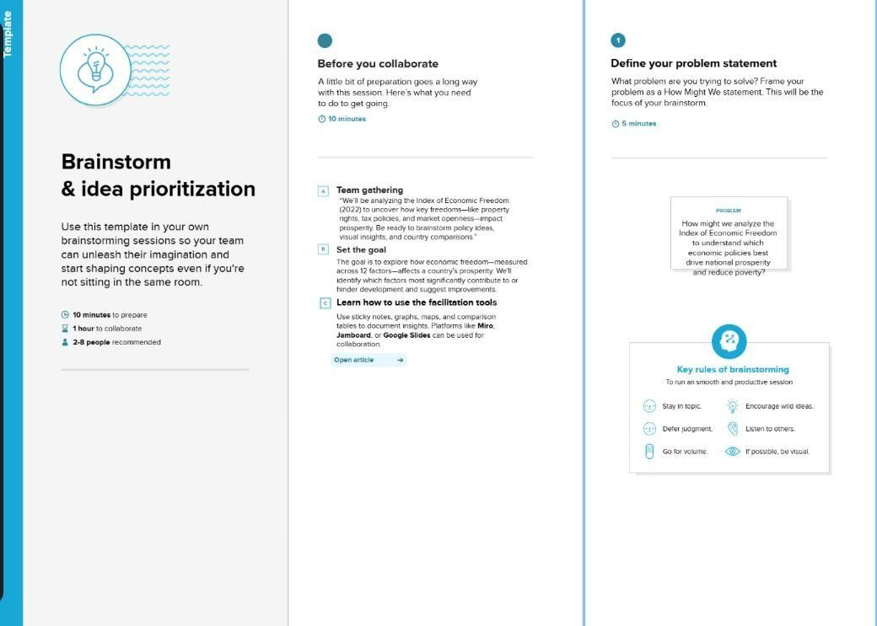

**Step-2: Brainstorm, Idea Listing and Grouping**

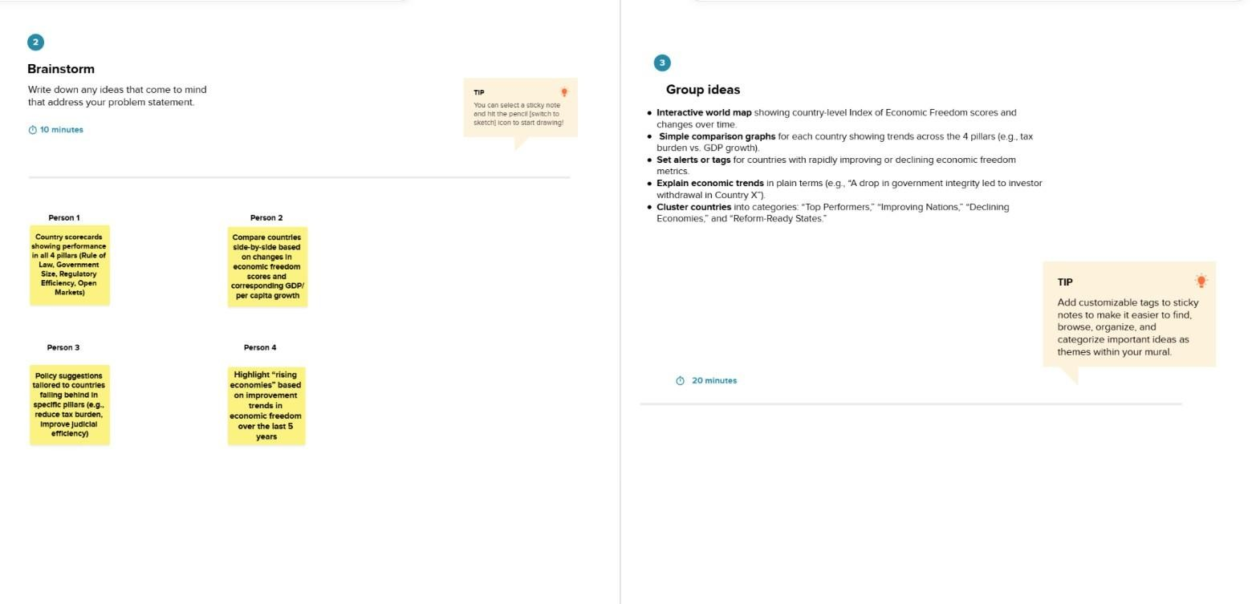

**Step-3: Idea Prioritization**

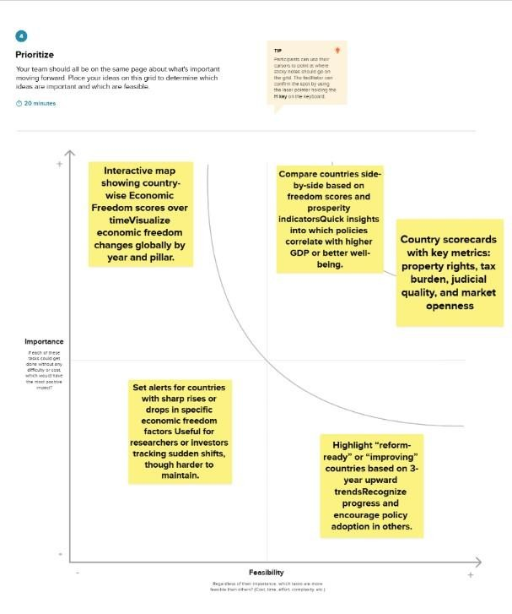

## 3. REQUIREMENT ANALYSIS 3.1 Customer Journey map

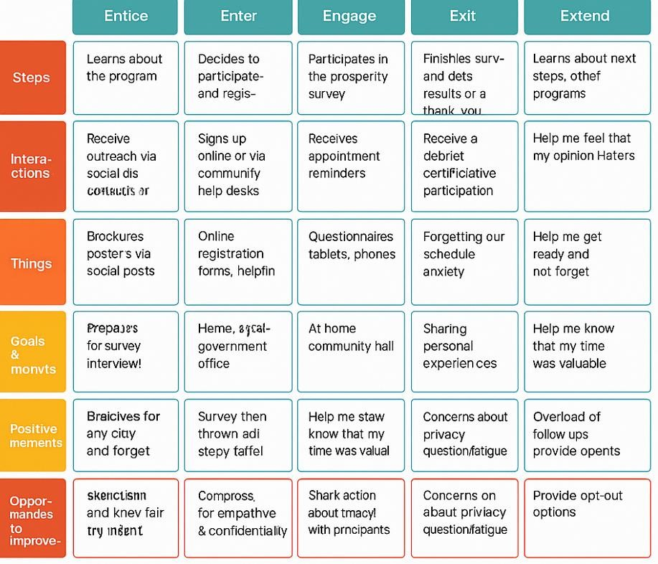

### 3.2 Solution Requirement

**Functional Requirements:**

Following are the functional requirements of the proposed solution.

|  |  |  |
| --- | --- | --- |
| **FR No.** | **Functional**  **Requirement**  **(Epic)** | **Sub Requirement (Story / SubTask)** |
| FR-1 | Data Upload | Upload Economic Freedom Index  CSV files  Upload GDP and HDI datasets |
| FR-2 | Data  Preprocessing | Data cleaning and formatting using Python  Handling missing or null values |
| FR-3 | Visualization | Create country-wise comparative dashboards  Implement correlation  visualizations between freedom &  GDP  Add dynamic filters for year, region, and economic tier |
| FR-4 | Insight Extraction | Identify top/bottom performing nations  Show pattern-based insights via story dashboards |
| FR-5 | Export Options | Export dashboards to PDF or PNG Allow download of filtered datasets |

**Non-functional Requirements:**

Following are the non-functional requirements of the proposed solution.

|  |  |  |
| --- | --- | --- |
| FR No. | Non-Functional Requirement | Description |
| NFR-1 | Usability | Dashboards should be intuitive and easy to  interpret for all stakeholders |
| NFR-2 | Security | File upload/download permissions, view-only access on dashboards |
| NFR-3 | Reliability | Data visualizations should render correctly across all filters |
| NFR-4 | Performance | Dashboards should load within 3 seconds on average |
| NFR-5 | Availability | Published dashboards must be accessible 24/7 |
| NFR-6 | Scalability | New datasets should be easily ingestible without structural changes |

### 3.3 Data Flow Diagram

**User Stories**

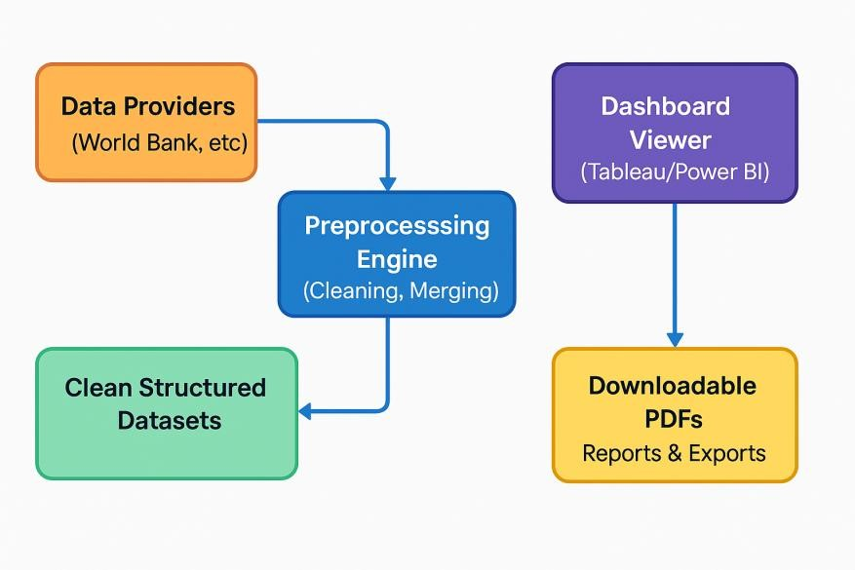

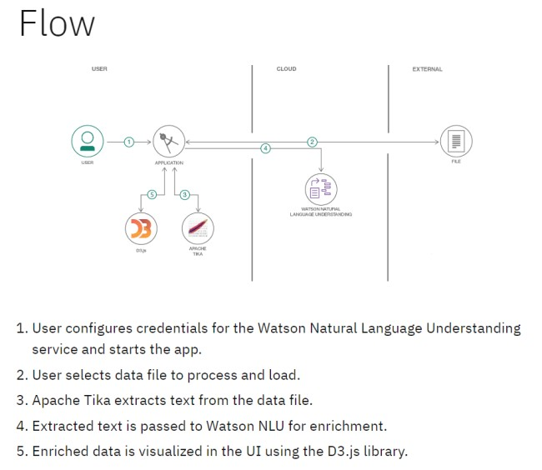

# 4. PROJECT DESIGN

## 4.1 Problem Solution Fit

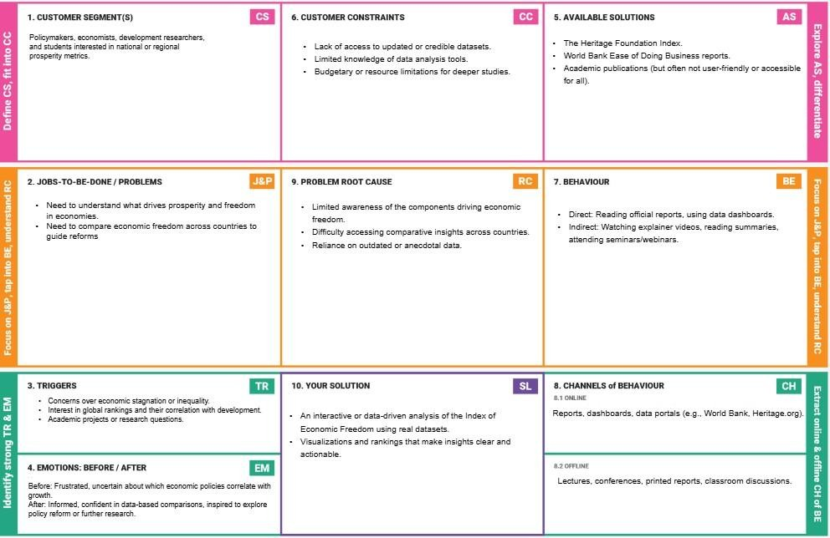

## 4.2 Proposed Solution

**Proposed Solution Template:**

Project team shall fill the following information in the proposed solution template

|  |  |  |
| --- | --- | --- |
| **S.No.** | **Parameter** | **Description** |
| 1. | Problem Statement (Problem to be solved) | Despite the availability of macroeconomic data, policymakers and researchers lack a clear, accessible method to evaluate how economic freedom correlates with prosperity. |
| 2. | Idea / Solution description | The project analyses the Economic Freedom Index using data visualization and comparative analysis tools. It offers clear dashboards, insights, and recommendations across countries |
| 3. | Novelty / Uniqueness | While reports exist, this solution provides an interactive, comparative, and visually rich platform combining multiple data dimensions useful for academia and policy |
| 4. | Social Impact / Customer Satisfaction | Informed citizens, better policy decisions, and transparency in economic governance. This tool helps identify reforms needed to enhance freedom and economic performance. |
| 5. | Business Model (Revenue Model) | Can be offered as a freemium tool for students/researchers, with advanced insights and country reports available via subscription for institutions, think tanks, or NGOs. |
| 6. | Scalability of the Solution | Can be extended to include regional/state-level indices, time-series trends, or integration with other indicators (e.g., Human Development Index, Corruption Perception Index). |

## 4.3 Solution Architecture

**Example:** [**(Simplified)**](https://developer.ibm.com/patterns/visualize-unstructured-text/)

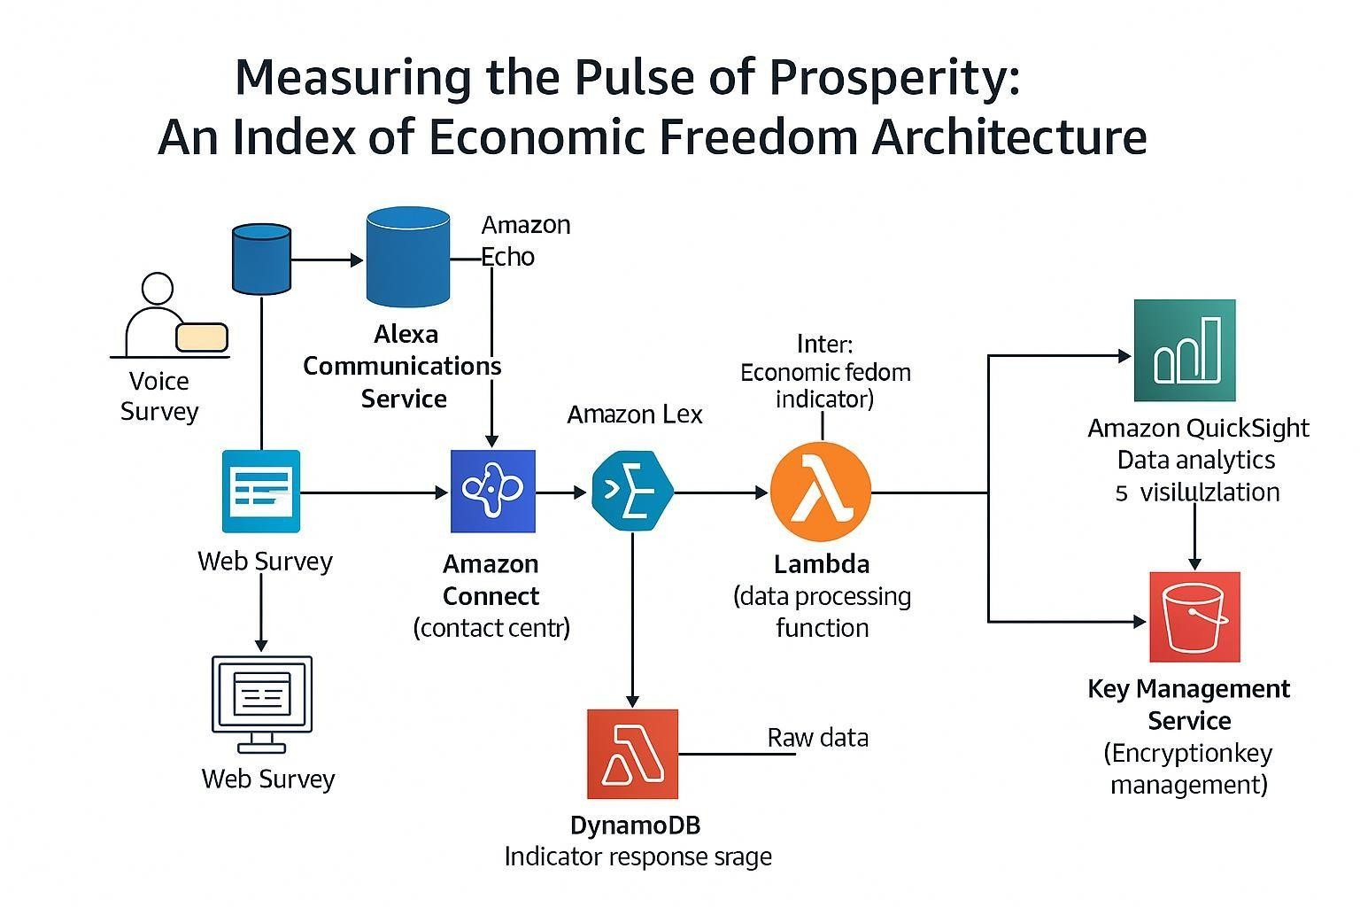

# 5. PROJECT PLANNING & SCHEDULING

## 5.1 Project Planning

|  |  |  |  |  |  |
| --- | --- | --- | --- | --- | --- |
| **Sprint** | **Functional**  **Requirement**  **(Epic)** | **User**  **Story**  **Number** | **User Story / Task** | **Story Points** | **Priority** |
| Sprint-1 | Data Analysis  &  Visualization | USN-1 | As a Policymaker, I want to view a world map showing economic freedom scores by country, so that I can quickly identify regions with high or low economic prosperity and potential policy impact areas. | 2 | High |
| Sprint-1 | Data Analysis  &  Visualization | USN-2 | As an Economic Researcher, I want to filter economic data by specific years and countries, so that I can conduct in-depth analysis on historical trends and compare performance across different nations. | 2 | High |
| Sprint-1 | Data Analysis  &  Visualization | USN-3 | As an Investor, I want to see the top 40 and least ranked countries based on their economic index, so  that I can identify potential investment opportunities or risks in various markets. | 2 | High |
| Sprint-2 | Data  Ingestion &  Management | USN-4 | As a User, I want to upload new economic datasets (e.g., CSV, Excel), so that I can incorporate the latest information into the analysis and update the index | 3 | Medium |
| Sprint-2 | Data Analysis  &  Visualization | USN-5 | As an Economic Researcher, I want to view correlations between economic freedom and indicators like unemployment rate and GDP growth, so that I can understand the multifaceted impacts of economic policies. | 4 | High |
| Sprint-3 | Reporting & Export | USN-6 | As a User, I want to export visualizations (e.g., charts, maps) as image files, so that I can easily include them in presentations or reports. | 4 | Medium |
| Sprint-3 | User Management  &  Authorization | USN-7 | As an Administrator, I want to manage user accounts and roles, so that I can access levels to sensitive data and functionalities. | 3 | High |

**Project Tracker, Velocity & Burndown Chart:**

|  |  |  |  |  |  |  |
| --- | --- | --- | --- | --- | --- | --- |
| **Sprint** | **Total Story Points** | **Duration** | **Sprint Start Date** | **Sprint End Date**  **(Planned)** | **Story Points**  **Completed**  **(as on**  **Planned End**  **Date)** | **Sprint Release Date (Actual)** |
| Sprint-1 | 6 | 5 Days | 16 June 2025 | 21June 2025 | 6 | 21 June 2025 |
| Sprint-2 | 7 | 5 Days | 21June 2025 | 25 June 2025 | 7 | 25 June 2025 |
| Sprint-3 | 7 | 5 Days | 25 June 2025 | 30 June 2025 |  |  |

**Velocity:**

Imagine we have a 10-day sprint duration, and the velocity of the team is 20 (points per sprint). Let’s calculate the team’s average velocity (AV) per iteration unit (story points per day)  **AV = sprint duration/velocity =15/10=1.5**

**Burndown Chart:**

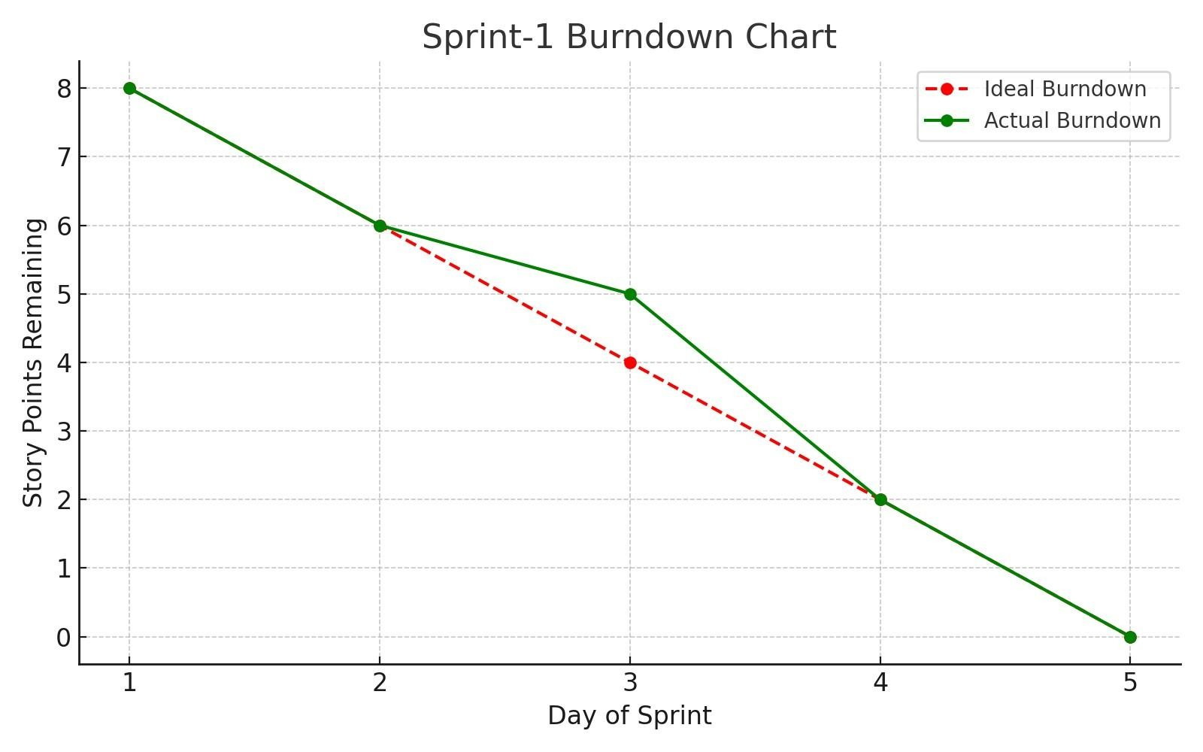

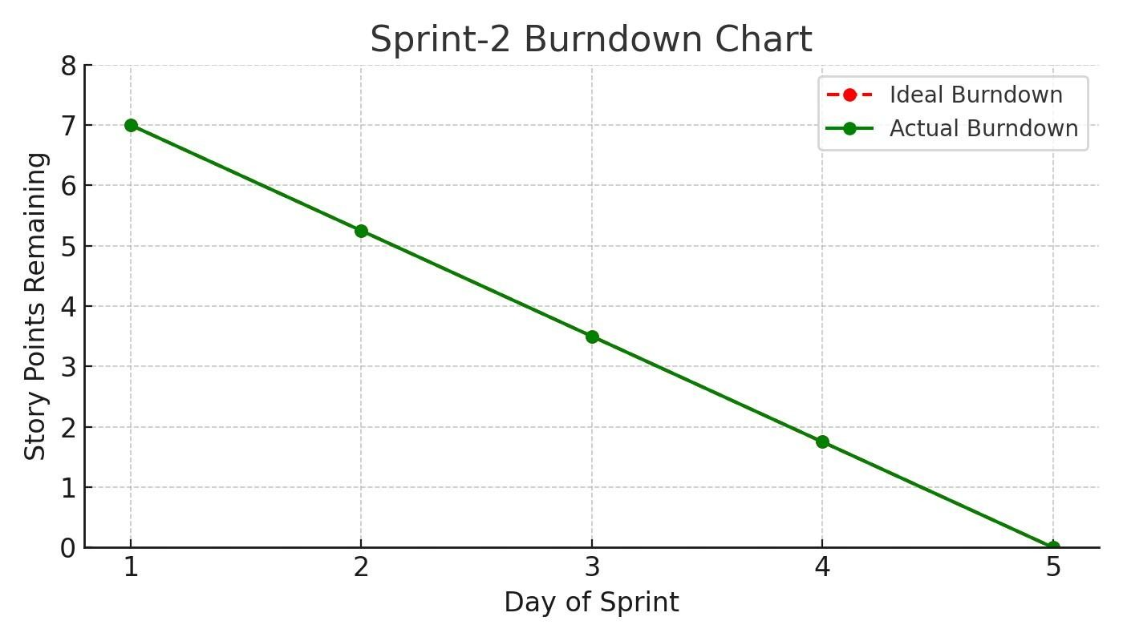

## 6. FUNCTIONAL AND PERFORMANCE TESTING

### 6.1 Performance Testing

**Model Performance Testing:**

Project team shall fill the following information in model performance testing template.

|  |  |  |
| --- | --- | --- |
| **S N**  **0** | **Parameter** | **Screenshot / Values** |
| 1. | Data Rendered | The dashboard renders comprehensive countrylevel  economic data including:   * Economic Score/Index * Country ID and Country Name * 5-Year GDP Growth Rate * Business Freedom, Corporate Tax Rate (%), FDI Inflow   (Millions), Financial Freedom, Fiscal Health, GDP (Billions),  GDP Growth Rate (%), GDP per Capita (PPP),  Government  Integrity, Government Expenditure (%) of GDP, |

|  |  |  |
| --- | --- | --- |
|  |  | Government Spending, Income Tax Rate (%), Inflation (%),  Index of Population, Unemployment (%). -The data appears to cover multiple years, showing trends  and comparisons across a wide range of countries. |
| 2. | Data  Preprocessing | Preprocessing likely involved:   * **Data Cleaning:** Handling missing values, correcting   inconsistencies, and standardizing country names.   * **Data Transformation:** Aggregating data to specific years   or regions, potentially calculating the composite Economic  Freedom Index from its constituent components. - **Geographic Data Preparation:** Ensuring country names  are recognized by Tableau for mapping.   * **Feature Engineering:** Creating calculated fields such as "5   Year GDP Growth Rate" or specific "Economic Score" components if not directly present in the raw data. |
| 3 | Utilization of Filters | The dashboard extensively uses filters and interactive  elements:   * **Country Name Filter:** Allows users to select specific   countries for focused analysis.   * **Measures Filter:** To select different economic indicators   (e.g., Inflation, Unemployment, GDP) for visualization and  Correlation      **Year Slider/Filter:** To change the year for which the data is displayed on the map and other charts. |

|  |  |  |
| --- | --- | --- |
|  |  | - **Interactive Map Selection:** Clicking on countries on the map appears to filter other related views |
| 4 | Calculation fields Used | Based on the metrics and visualizations, the following  calculated fields are likely used:   * **Economic Score/Index:** A composite score derived from   various sub-indicators of economic freedom. - **5 Year GDP Growth Rate:** Likely a calculation based on  GDP values over a five-year period.   * **Rankings:** Calculated fields to determine and display the   "Top 40 countries rank of Economy" and "Least ranked  countries of economic index."   * **Region Groupings:** Possibly a calculated field to group   countries into broader regions for high-level analysis. |
| 5 | Dashboard design | No of Visualizations / Graphs –  The primary dashboard ("Dashboard 1" / "Global Rankings  & Financial Freedom Impact Dashboard") contains at least 5  distinct visualizations/sections   * Choropleth Map (e.g., "Visualizing Economic Freedom and   Instability Around the World")   * Correlation Chart (e.g., "Correlation of Countries Based on   Inflation & Unemployment")   * Horizontal Bar Chart (e.g., "Index of   Population")   * "Insights Overview" Text Box * "Top 40 Countries rank of Economy" bar/map chart   -"Countries Less Than 25 of Economy Index"  (potentially a tree map or similar chart) |
| 6 | Story Design | No of Visualizations / Graphs – |
|  |  | The "Story" section ("Journey Through the 2002 Global  Economy") explicitly shows 5 story points/pages, each  potentially containing one or more visualizations:   * Story Point 1: World Map of Economic Score. * Story Point 2: Top 40 Countries Rank. * Story Point 3: Least Ranked Countries. * Story Point 4: Correlation of Countries Based on Inflation   & Unemployment.   * Story Point 5: Index of Population. * Story Point 6: Financial Freedom of Countries.   Story Point 7: Index of 5 yrs GDP Rate. |

## 7. RESULTS

### 7.1 Output Screenshots

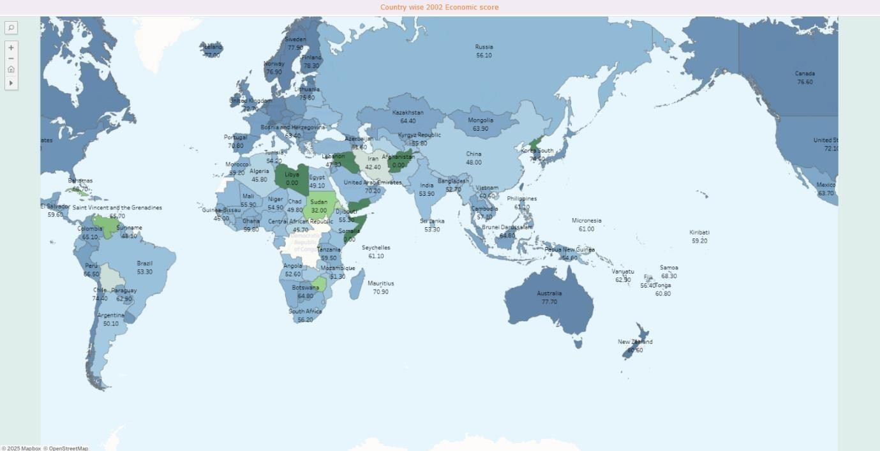

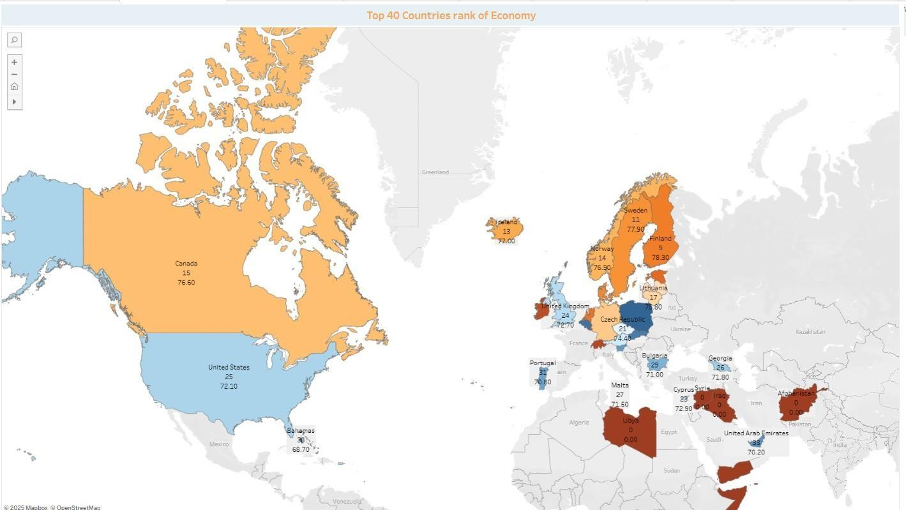

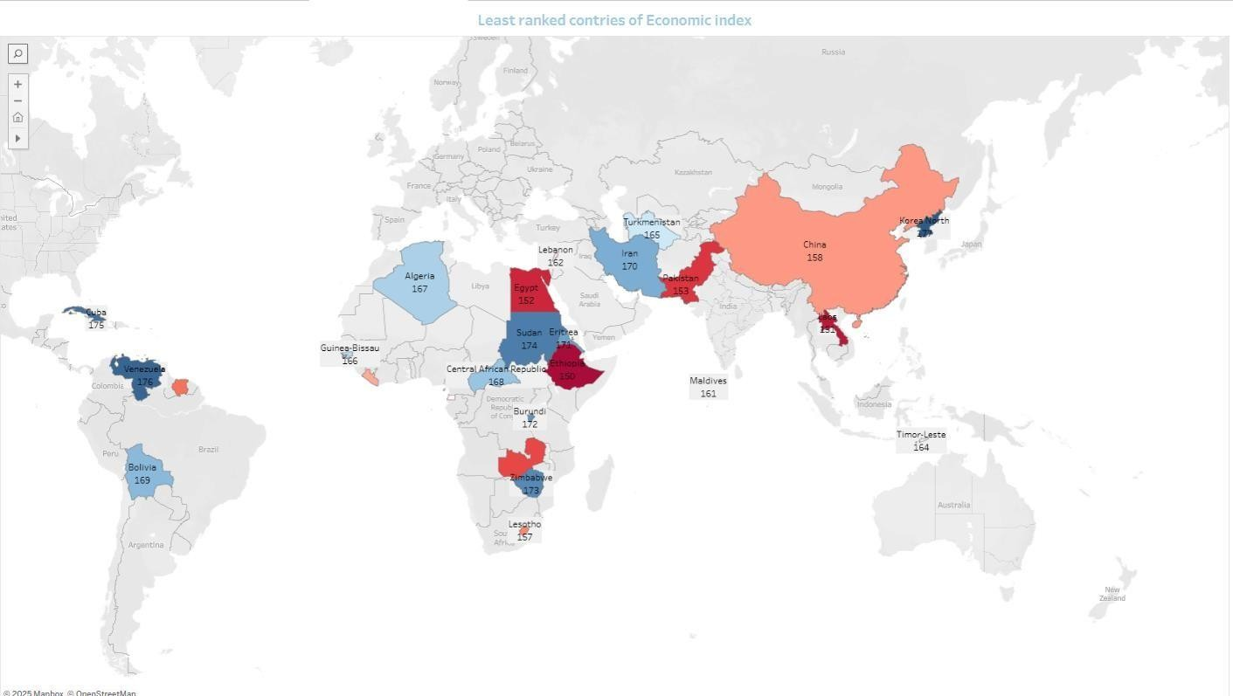

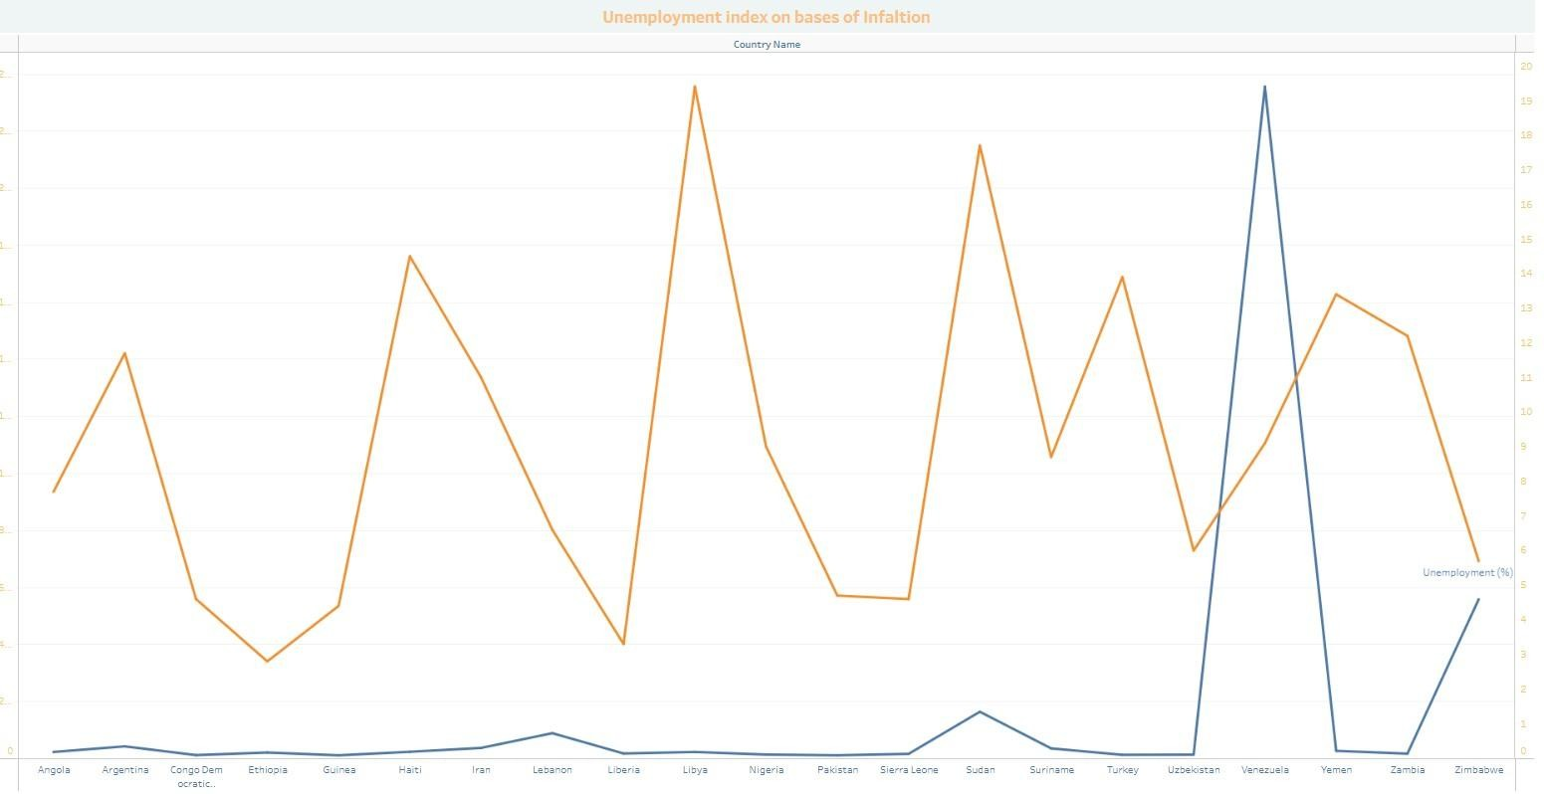

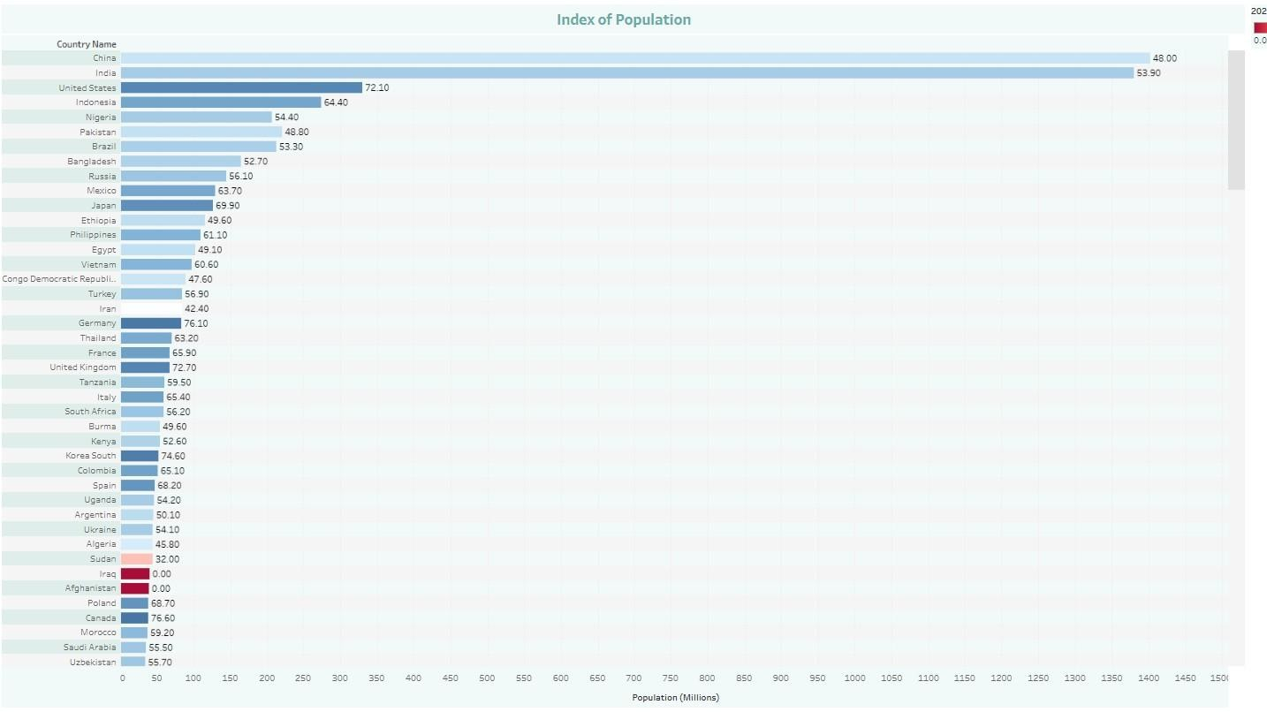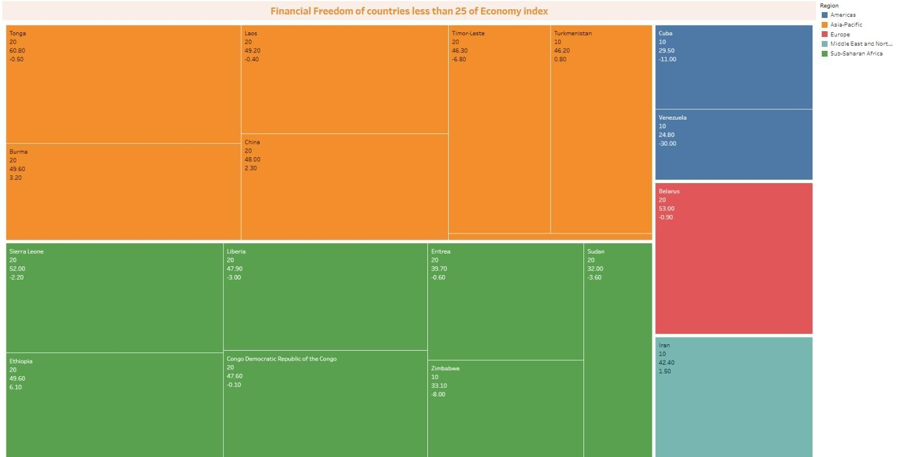

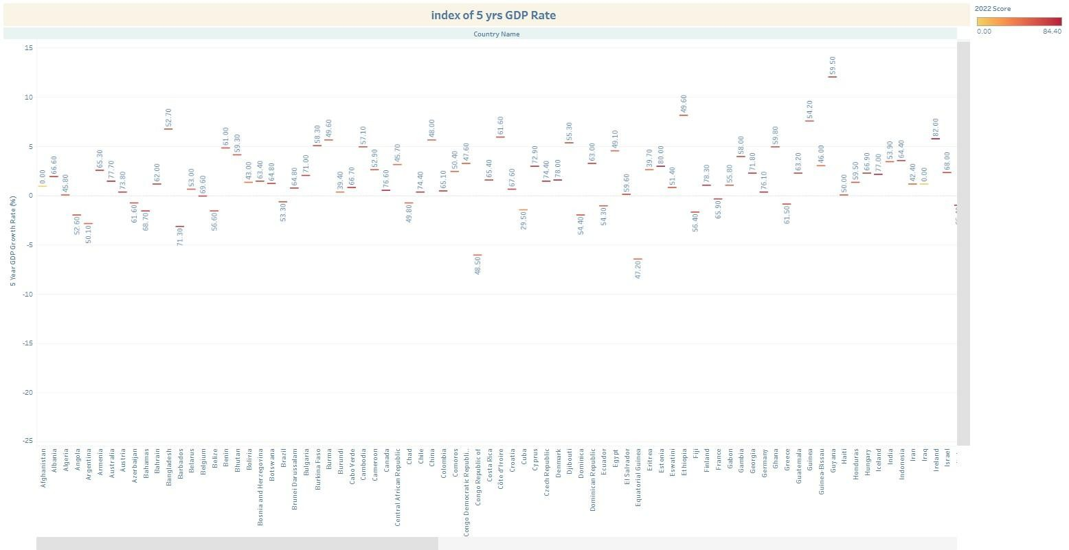

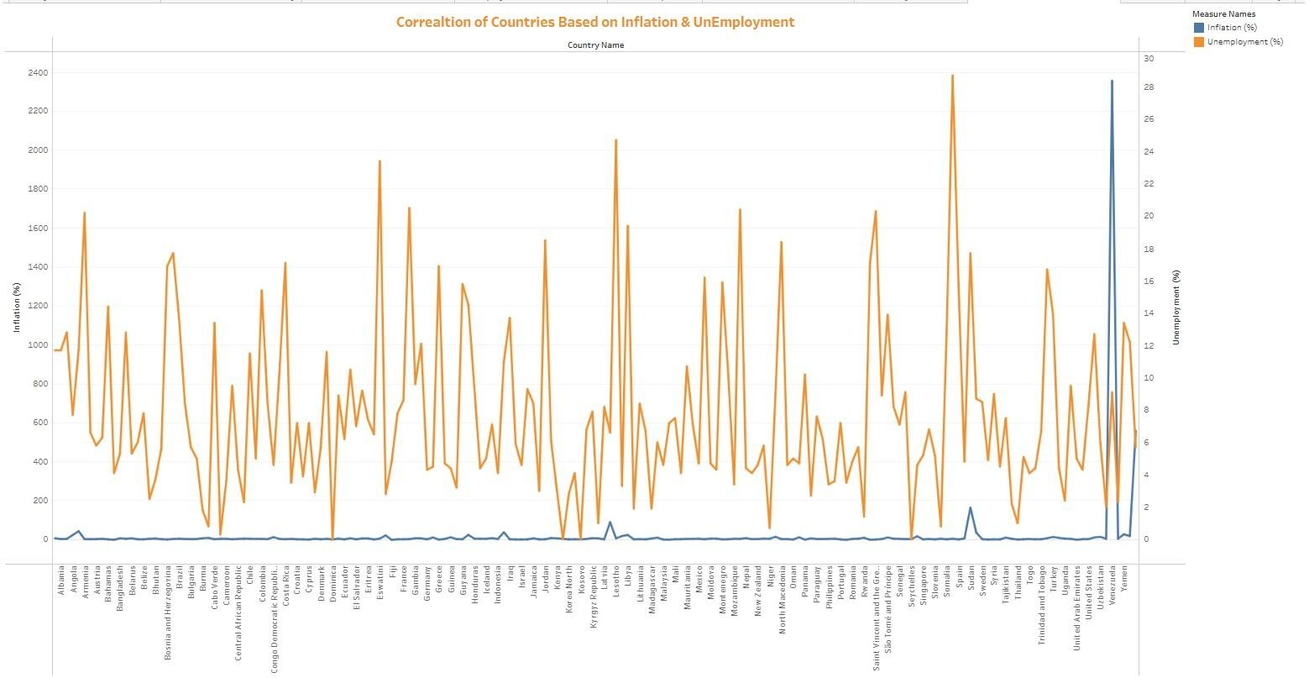

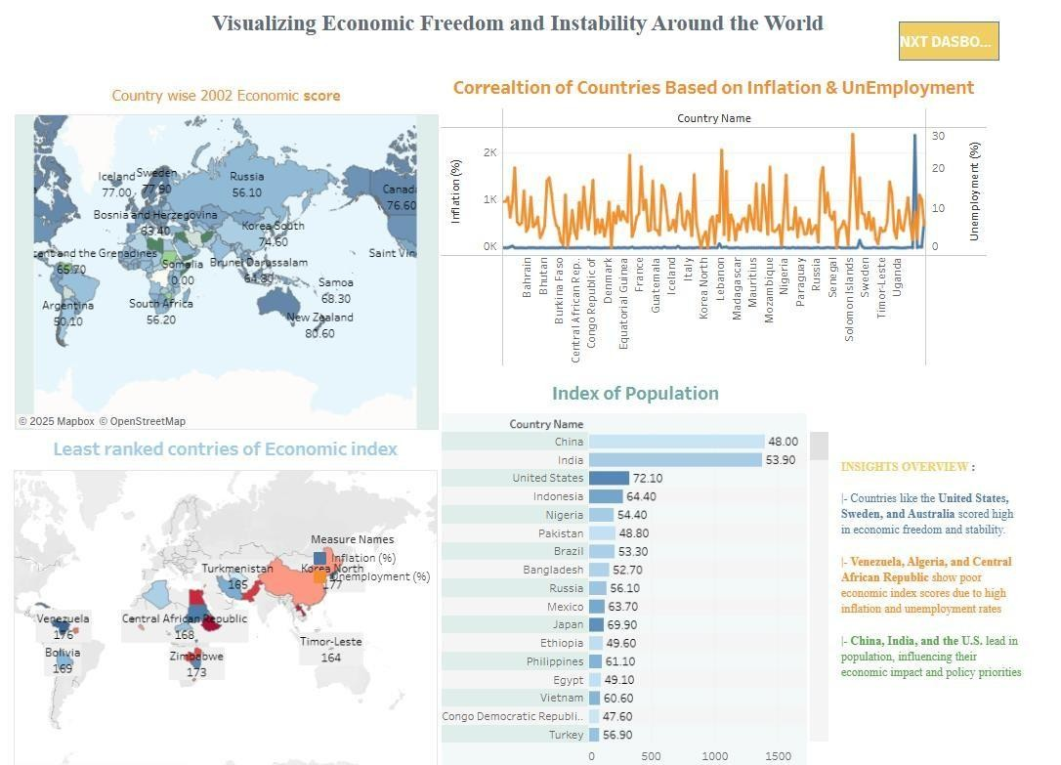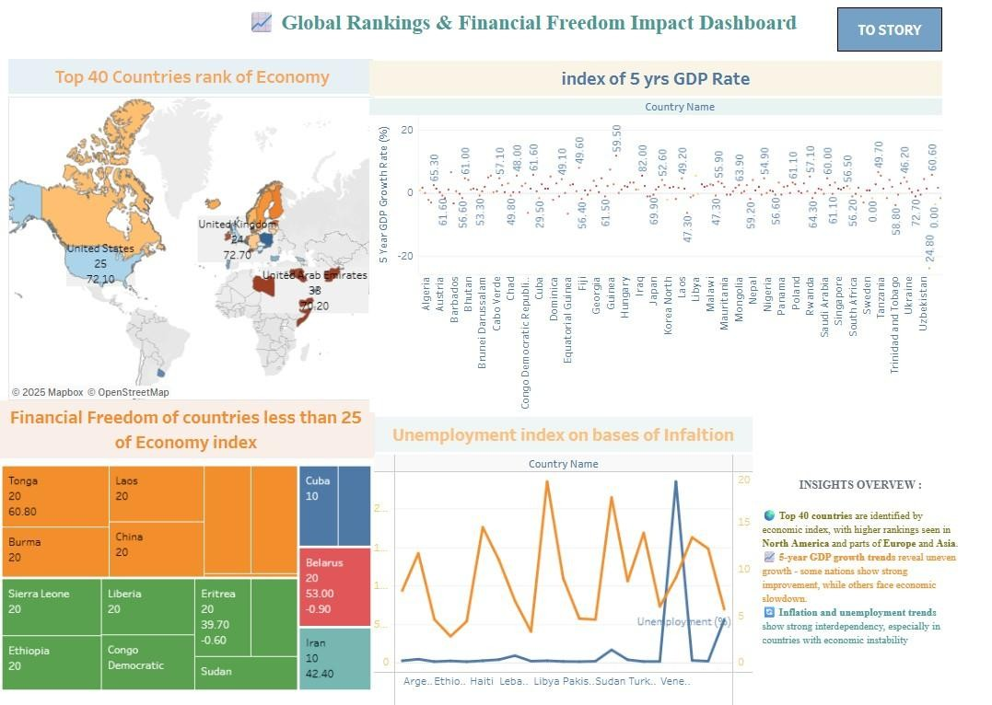

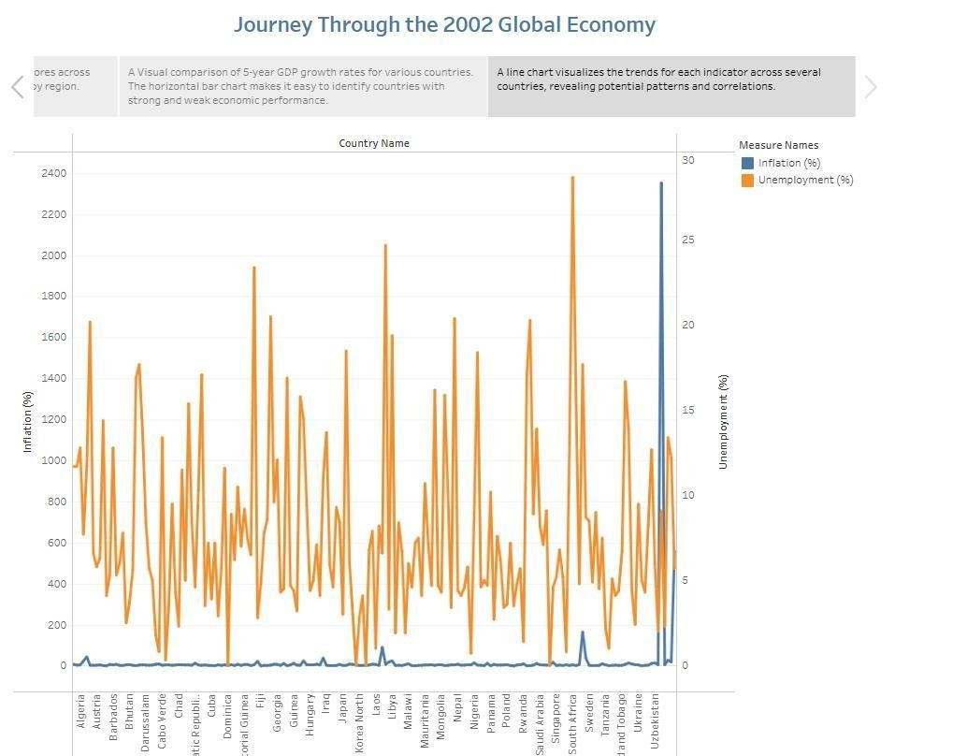

## 8. ADVANTAGES & DISADVANTAGES

### Advantages

1. Data-Driven Insights

Empowers users to make informed decisions using real-time, evidence-based economic indicators.

1. Interactive Visualization

User-friendly dashboards allow for filtering by year, country, and economic subindices, making analysis accessible to non-technical users.

1. Multi-Stakeholder Utility

Useful to policymakers, researchers, investors, and students alike, each gaining insights specific to their objectives.

1. Customizable & Scalable

The modular architecture allows easy integration of new datasets, indicators, or visualization layers.

1. Open-Source & Cost-Efficient

Built using open-source tools like Python, Plotly, and Streamlit, reducing development and deployment costs. **Disadvantages**

1. Data Source Dependency

The analysis is limited to the scope and accuracy of available datasets like those from the Heritage Foundation or World Bank.

1. Limited Real-Time Updates

Economic freedom indices are not updated frequently, which may affect relevance for real-time policy decisions.

1. Technical Barriers for Non-Digital Users

Despite being user-friendly, some stakeholders without digital literacy may find the platform less accessible.

1. Infrastructure Limitations

Hosting and processing large datasets or high user traffic could require scaling the cloud infrastructure, leading to additional costs.

**9. CONCLUSION:**

The project “Measuring the Pulse of Prosperity: An Index of Economic Freedom Analysis” successfully demonstrates the power of data analytics and visualization in transforming static economic data into meaningful, actionable insights. By leveraging open-source tools and interactive dashboards, the platform bridges the gap between complex economic indicators and userfriendly interpretation.

This solution empowers policymakers, researchers, and investors to explore global economic trends, identify policy gaps, and make evidence-based decisions. The integration of filtering, correlation analysis, and exportable visualizations enhances the usability and adaptability of the system across various domains.

Through this initiative, we’ve laid a scalable foundation for deeper exploration of how economic freedom shapes prosperity—enabling smarter governance, more informed investment, and a clearer understanding of global economic landscapes.

## 10. FUTURE SCOPE

* Integration of Real-Time Economic Indicators

Future versions of the platform can incorporate APIs for real-time data (e.g., GDP updates, inflation, employment) to enhance the system’s relevance for ongoing policy and market analysis.

* Expanded Dataset Coverage

The project can be extended to include regional/state-level data, enabling microeconomic analysis within countries and more localized policymaking insights.

* Machine Learning-Based Forecasting

Implementing predictive models can help forecast future economic freedom scores or prosperity indicators based on historical patterns and current inputs.

* User Personalization and Notifications

Future iterations could allow user accounts with saved filters, email alerts for new reports, or policy shifts relevant to selected countries.

**11.APPENDIX**

**Dataset Link:**[**https://drive.google.com/file/d/1tXmujRaOmP3NT9-rgUGqk7DC6rT-7AgN/view?usp=sharing**](https://drive.google.com/file/d/1tXmujRaOmP3NT9-rgUGqk7DC6rT-7AgN/view?usp=sharing)

**Video Demo Link:**[**https://drive.google.com/file/d/1oEsaoEZyqAIc5AgDBlLdONXexc36LN16/view?usp=sharing**](https://drive.google.com/file/d/1oEsaoEZyqAIc5AgDBlLdONXexc36LN16/view?usp=sharing)

**GitHub Project Repository Link:**[**https://github.com/Shaik-Kashifa-Misba/Measuring-the-Pulse-of-Prosperity-An-Index-of-Economic-Freedom-Analysis**](https://github.com/Shaik-Kashifa-Misba/Measuring-the-Pulse-of-Prosperity-An-Index-of-Economic-Freedom-Analysis)